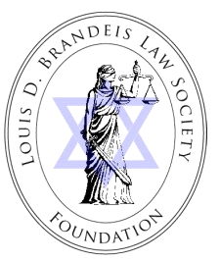

2018 APPLICATION
Louis D. Brandeis Law Society Foundation
Brandeis Law Society Young Lawyer Public Service Award

The Brandeis Law Society Young Lawyer Public Service Award is a $2500 cash prize given to a Jewish member of the Pennsylvania Bar in practice three years or less and a member of the Louis D. Brandeis Law Society who is currently employed in a legal capacity in either the public sector or a non-profit organization, has demonstrated a commitment to public service, and has shown outstanding leadership, professional achievement, and promise for future excellence.

NAME:
ADDRESS:
PHONE:
EMAIL:
DATE OF ADMISSION TO THE PENNSYLVANIA BAR:
CURENT EMPLOYER:

WITH THIS APPLICATION PLEASE ATTACH THE FOLLOWING:

1) A one page personal statement which introduces you and your background, outlines your qualifications for this Award, describes your professional activities and achievements, your involvement in public service and goals for the future;

2) A current resume; and

3) A letter of nomination in a sealed envelope from an individual who is knowledgeable of the criteria for the Award and the nominee’s credentials, achievements and commitment that make the nominee well qualified to be considered for this Award.

Application packages must be received on or before May 5, 2018 at the following office:

Brandeis Law Society Foundation
c/o Hon. A. Michael Snyder (ret.)
The Dispute Resolution Institute
2 Logan Square, Suite 660
18th and Arch Streets
Philadelphia, PA 19103

If you have any questions, please contact Judge Snyder at 215-656-4091, or email at msnyder@adrdri.com. The Brandeis Law Society Young Lawyer Public Service Award will be presented at the Annual Scholarship Event sponsored by the Brandeis Law Society Foundation on Tuesday, May 22, at 5:30 P.M. at The Society of Colonial Dames, 1630 Latimer Street, Philadelphia, PA.

It is expected that the recipient will be present to accept the award.

